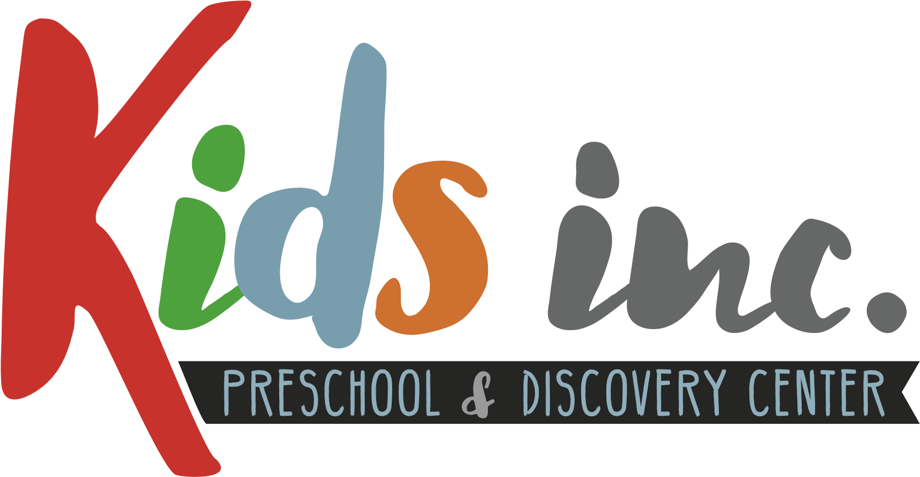
Kids inc 2021 Holiday

January 1, 2021 New Year’s Day
January 18, 2021 Martin Luther King Day
February 15, 2021 President’s Day
May 31, 2021 Memorial Day
July 5, 2021 Independence Day (Observed)
August 6, 2021 Staff in Service Day
September 6, 2021 Labor Day
November 11, 2021 Veteran’s Day
November 25, 2021 Thanksgiving Day
November 26, 2021 Thanksgiving Break
December 24, 2021 Christmas Eve
December 31, 2021 New Year’s Eve

